DBS & DS PRACTIAL WEEK -1

mysql> CREATE DATABASE IF NOT EXISTS bookflow_db;
Query OK, 1 row affected, 1 warning (0.04 sec)

mysql> USE bookflow_db;
Database changed

mysql> CREATE TABLE books (
-> book_id INT AUTO_INCREMENT PRIMARY KEY,
-> title VARCHAR(255) NOT NULL,
-> isbn VARCHAR(13) NOT NULL UNIQUE,
-> published_year INT,
-> CONSTRAINT chk_published_year CHECK (published_year < 2027)
-> );
Query OK, 0 rows affected (0.10 sec)

mysql> CREATE TABLE members (
-> member_id INT AUTO_INCREMENT PRIMARY KEY,
-> full_name VARCHAR(100) NOT NULL,
-> email VARCHAR(150) NOT NULL UNIQUE
-> );
Query OK, 0 rows affected (0.10 sec)

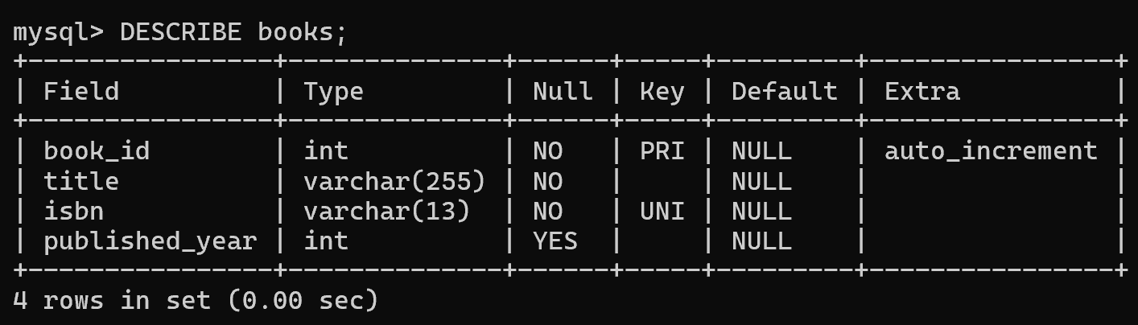
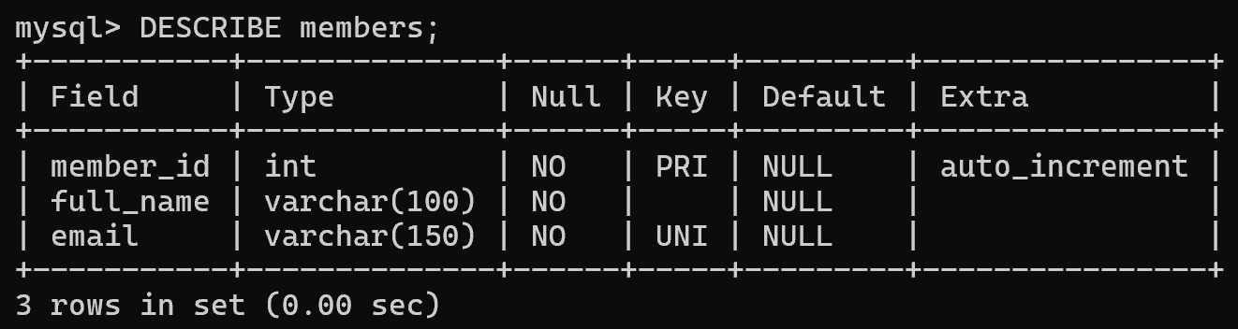

mysql> INSERT INTO books (title, isbn, published_year) VALUES
-> ('JAVA', '9781234567890', 1988),
-> ('DBMS', '9781234567891', 2008),
-> ('ML', '9781234567892', 2018);
Query OK, 3 rows affected (0.04 sec)
Records: 3 Duplicates: 0 Warnings: 0

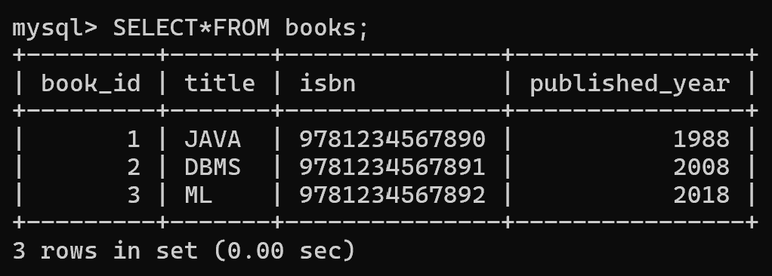

mysql> INSERT INTO members (full_name, email) VALUES
-> ('Anil Kumar', 'anil.kumar@example.com'),
-> ('Priya Sharma', 'priya.sharma@example.com'),
-> ('Ravi Verma', 'ravi.verma@example.com');
Query OK, 3 rows affected (0.04 sec)
Records: 3 Duplicates: 0 Warnings: 0
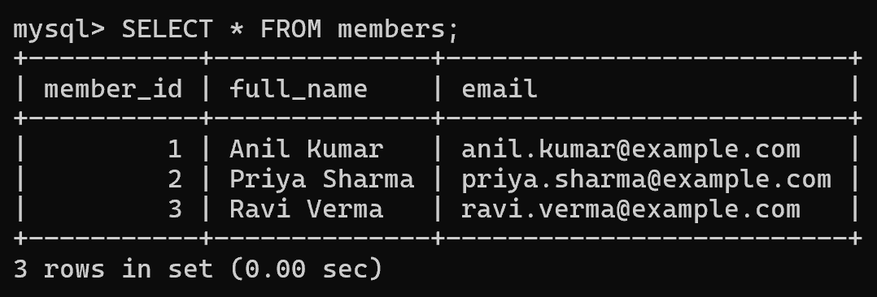

mysql> INSERT INTO books (title, isbn, published_year) VALUES
-> ('Fake Copy', '9780061122415', 2000);
Query OK, 1 row affected (0.01 sec)

mysql> INSERT INTO books (title, isbn, published_year) VALUES
-> (NULL, '9999999999999', 2010);
ERROR 1048 (23000): Column 'title' cannot be null

mysql> INSERT INTO books (title, isbn, published_year)
-> VALUES ('Time Traveler', '8888888888888', 2030);
ERROR 3819 (HY000): Check constraint 'chk_published_year' is violated.

mysql> INSERT INTO members (full_name, email)
-> VALUES ('Anil Clone', 'anil.kumar@example.com');
ERROR 1062 (23000): Duplicate entry 'anil.kumar@example.com' for key 'members.email'

